

**MANAV RACHNA UNIVERSITY, FARIDABAD**

**Department of Computer Science and Technology**

**Course: B.Tech (CST)**

**Subject: Programming for Problem Solving using Python(CSW208B) Session: 2020-21**

***Lab 1:*** *Understanding Jupyter IDE for creating and executing a Python program*

***Learning Outcome CO1*:** *Student will be able to get the Python environment up and running and the basics of Python programming language*

***Blooms Taxonomy Level****: BT1, BT2*

1. Introducing the Python language, Understanding the Python shell.
2. Development environment setup, Configuring – Installation of Anaconda IDE.
3. Introduction to Jupyter notebook.
4. Working with Jupyter notebook.
5. Writing a program to print a welcome message.

**CODE:**

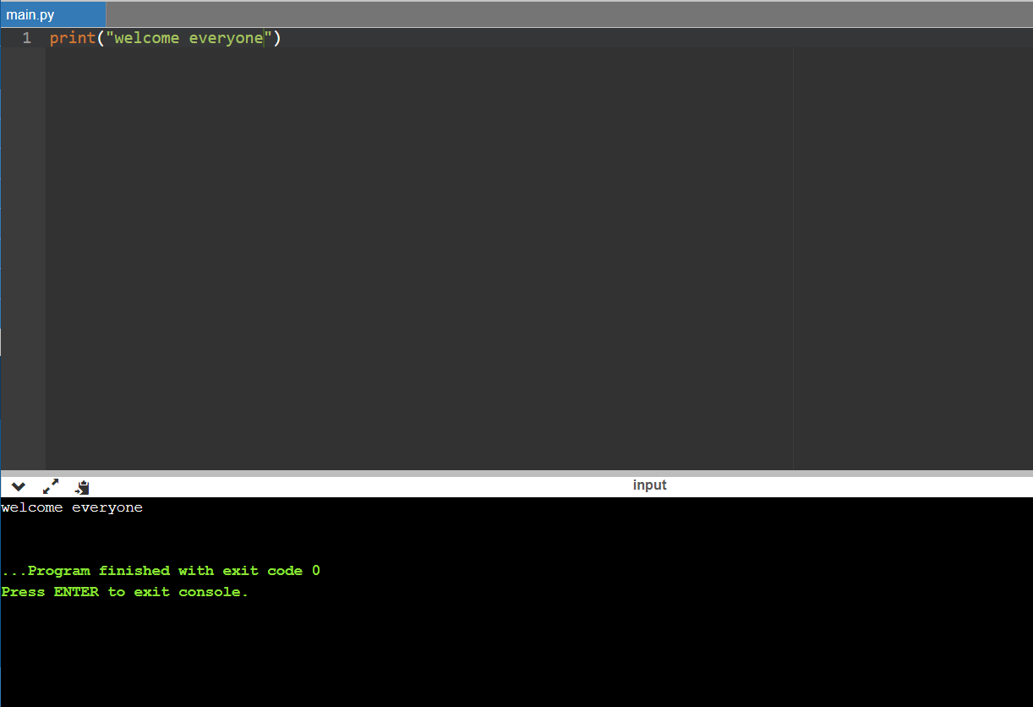

1. Write a program to add two numbers.

**CODE:**

x = input("Type a number: ")

y = input("Type another number: ")

sum = int(x) + int(y)

print("The sum is: ", sum)

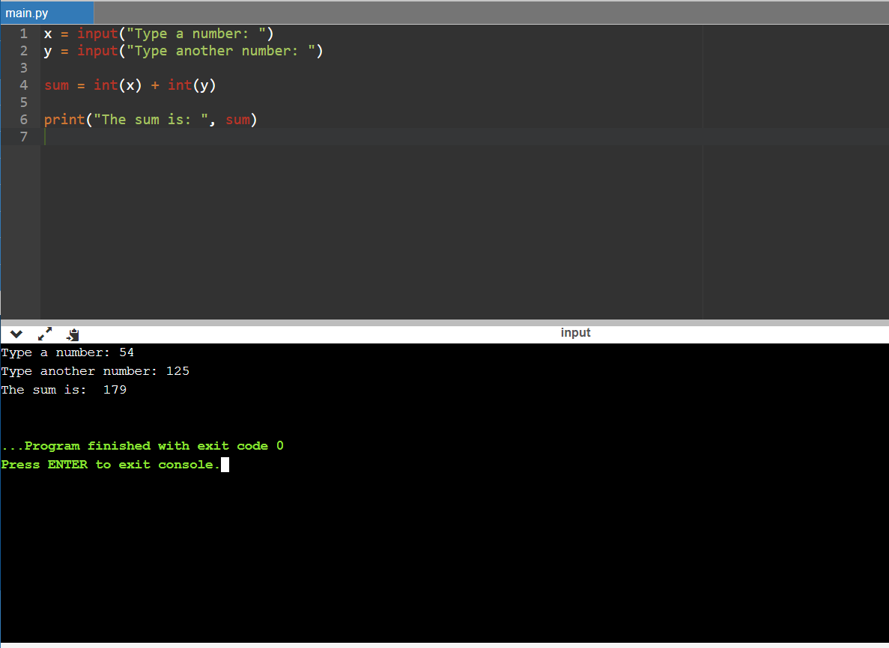

1. Write a program to take first name, middle name and last name from the user. Greet the user.

**CODE:**

fname=input("enter first name:")

mname=input("enter middle name:")

lname=input("enter last name :")

print("hello"," ",fname," ",mname," ",lname)

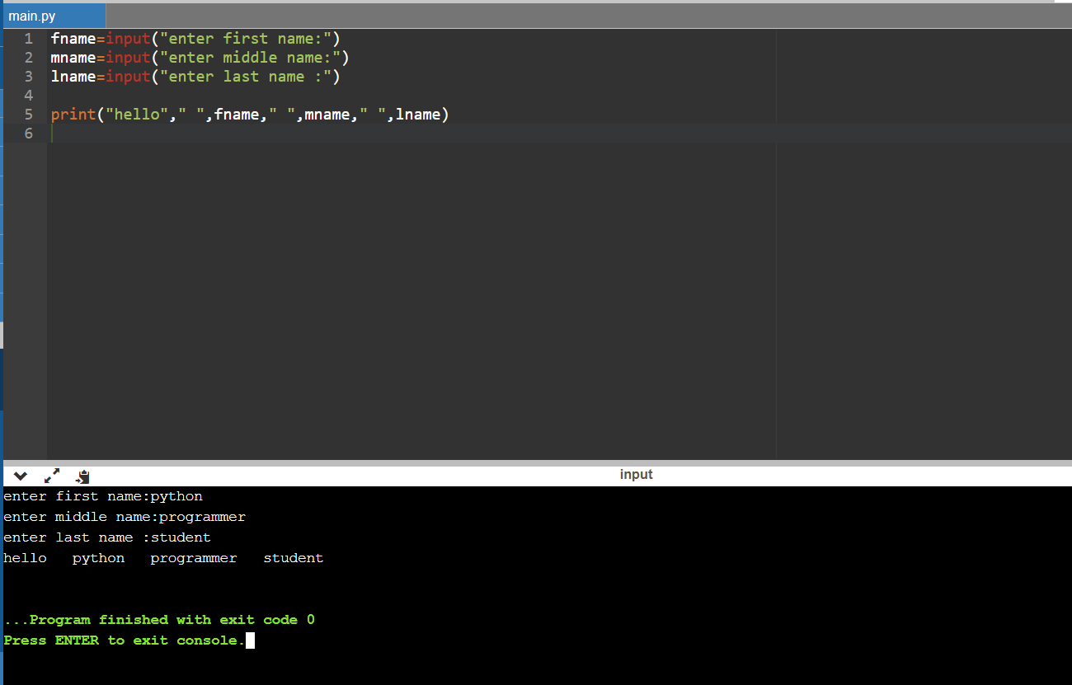

**LAB-2**

1. [Check whether a number is even or odd](https://www.programiz.com/python-programming/examples/prime-number)

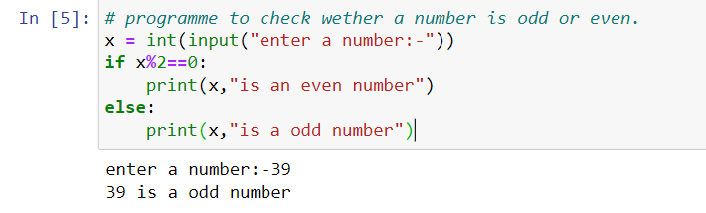

1. [Check whether an entered year is leap year or not.](https://www.programiz.com/python-programming/examples/prime-number)

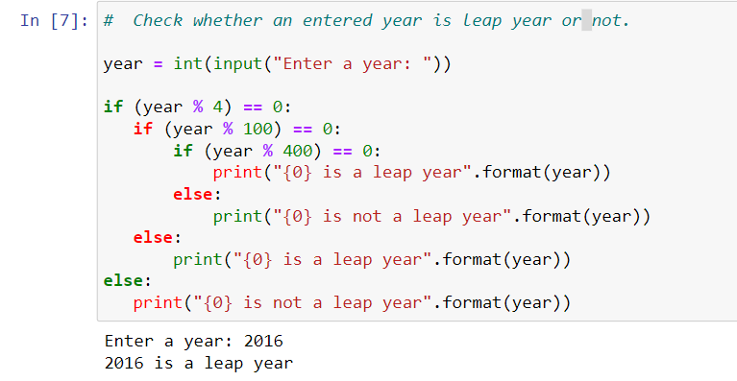

1. Write a program to check whether a character is vowel or consonants.

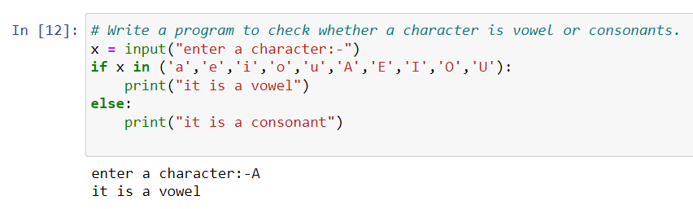

1. Write a program to find the smallest of two numbers.

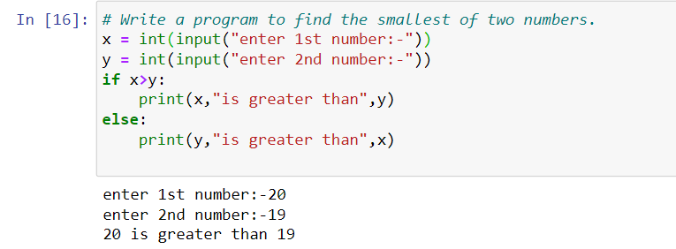

1. [Find the Factorial of a Number](https://www.programiz.com/python-programming/examples/factorial)

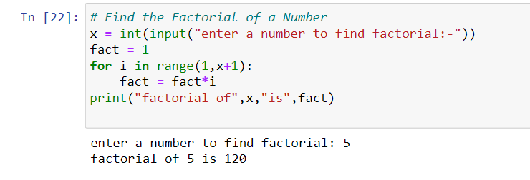

1. Write a program to print this patterns

*

* *

* * *

* * * *

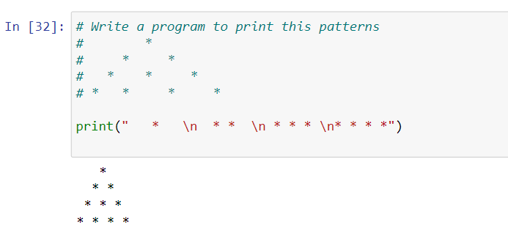

1. Write a program to print this series

1 1 2 3 5 8 13

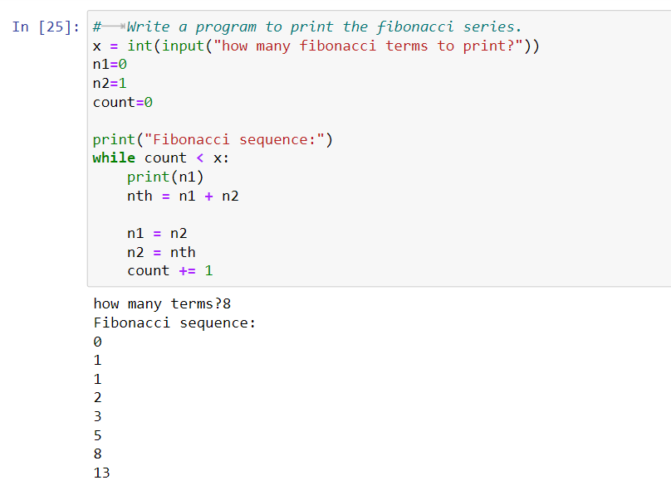

1. [Check whether a number is prime or not](https://www.programiz.com/python-programming/examples/prime-number)

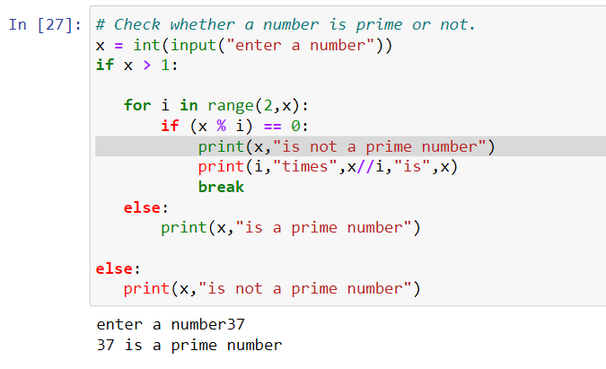

1. [Make a Simple Calculator](https://www.programiz.com/python-programming/examples/calculator).

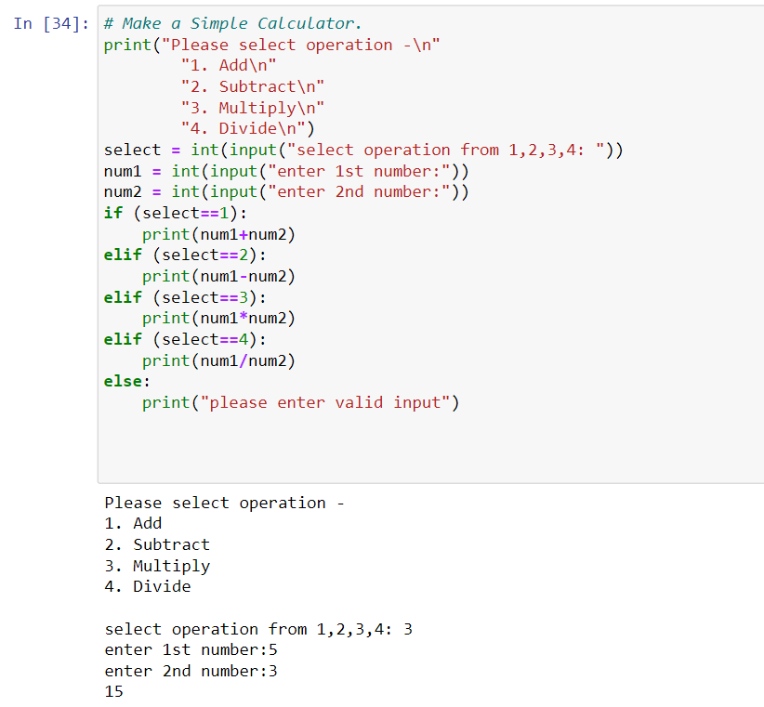

**LAB-3**

1.WAPtodemonstratewhileloopwithelsestatement.

#whileloopwithelsestatement

i=int(input("Entertheintegerless10:"))whilei<10:print(i)

i+=1else:print("iisnolongerlessthan10")

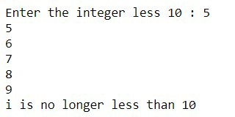

2.Print1st5evennumbers(usebreakstatement).

#firstfiveprimenumbersusingbreakstatementi=0c=1 print("FirstfiveevennumbersEvennumbers")foriin range(120):ifi%2==0: print(i) c+=1elifc>5: break

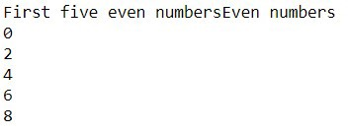

3.Print1st4evennumbers(usecontinuestatement).

#firstfourprimenumbersusingcontinuei=0c=1 print("FirstfiveevennumbersEvennumbers")foriin range(8):ifi%2!=0: c+=1 continueelifc<5: print(i)

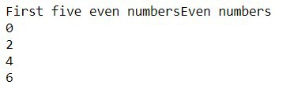

4.WAPtodemonstratePassstatements.

#Demonstratingpassstatementa= 10b=20if(a<b):passelse: print("b<a")

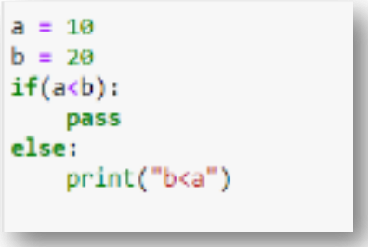

5.WriteaPythonprogramtocalculatethelengthofastring.

#Tocalculatethelengthofagivenstrings=input("Enter thestring:")print("Lengthofthestringis",len(s))

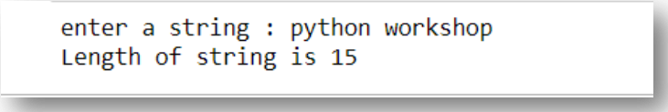

6.WriteaPythonprogramtocountthenumberofcharacters (characterfrequency)inastring

string=input()f={} foriinstring: f[i]=f.get(i,0)+1print(f)

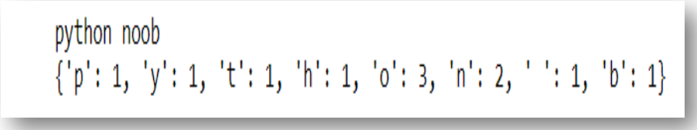

7.WriteaPythonprogramtogetastringmadeofthefirst2 andthelast2charsfromagivenastring.Ifthestringlength islessthan2,returninsteadoftheemptystring.

#Togetastringmadeofthefirst2andthelast2charsfromagivenastring s=input("Enterthestring:")print("Requiredoutput:

"+s[0:2]+s[-2:])

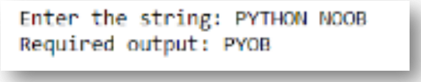

8.WriteaPythonprogramtogetasinglestringfromtwogiven strings,separatedbyaspaceandswapthefirsttwo charactersofeachstring.

a=input()b=input()x=a[0:2]

a=a.replace(a[0:2],b[0:2])

b=b.replace(b[0:2],x)print(a,b)

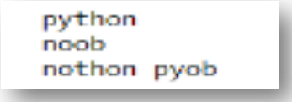

9.WriteaPythonprogramtoadd'ing'attheendofagiven string

(lengthshouldbeatleast3).Ifthegivenstringalreadyends with'ing'thenadd'ly'instead.Ifthestringlengthofthe givenstringislessthan3,leaveitunchanged

s=input()iflen(s)<3: print(s)elifs[-3:]=='ing': print(s+'ly')else:print(s

+'ing')



**LAB-4**

**Lab 4**

**Tuple**

1. Write a Python program to create a tuple.

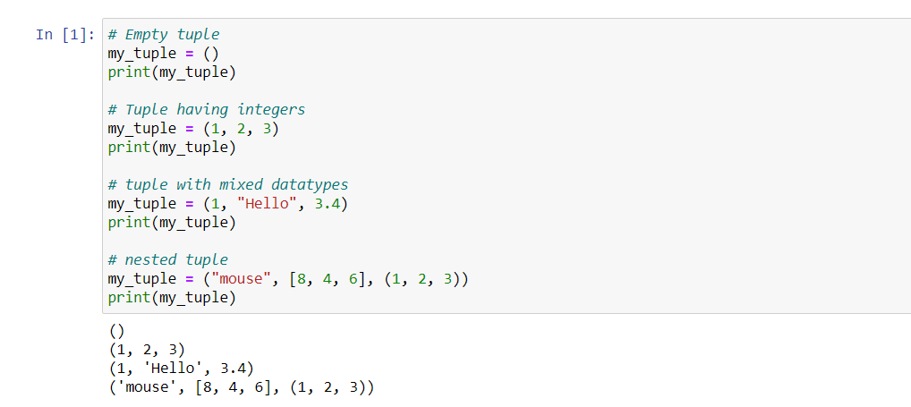

1. Write a Python program to create a tuple with different data types.

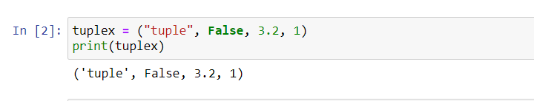

1. Write a Python program to create a tuple with numbers and print one item.

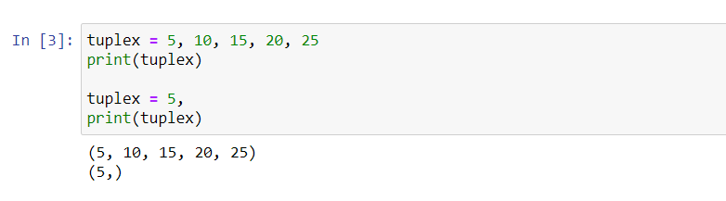

1. Write a Python program to unpack a tuple in several variables.

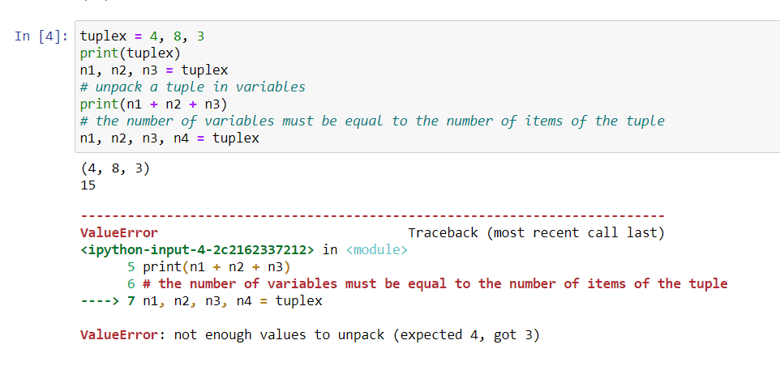

1. Write a Python program to add an item in a tuple.

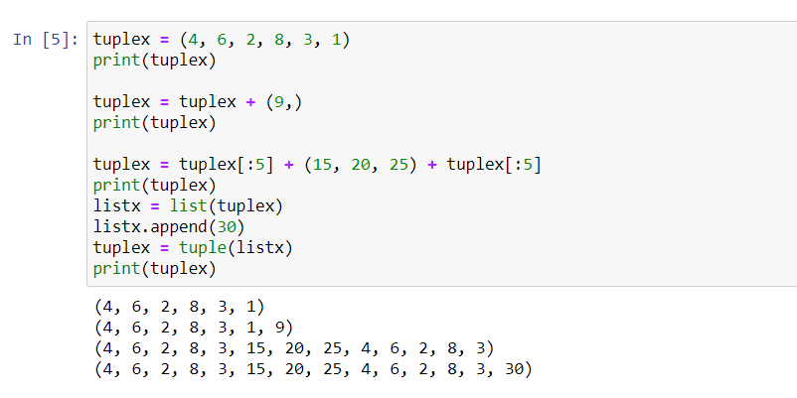

1. Write a Python program to convert a tuple to a string.

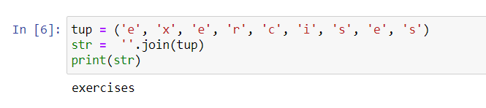

1. Write a Python program to get the 4th element and 4th element from last of a tuple

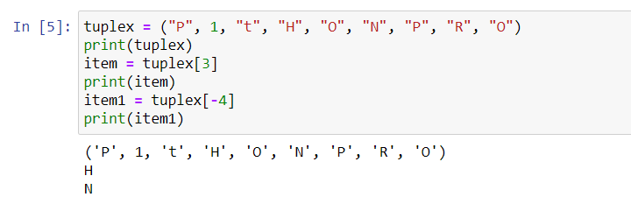

1. Write a Python program to create the colon of a tuple.

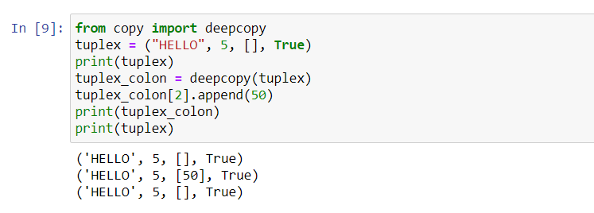

1. Write a Python program to find the repeated items of a tuple.

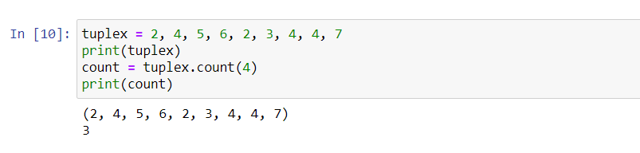

1. Write a Python program to check whether an element exists within a tuple.

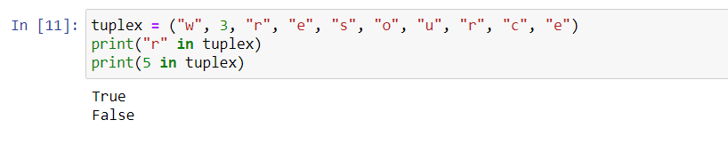

1. Write a Python program to convert a list to a tuple.

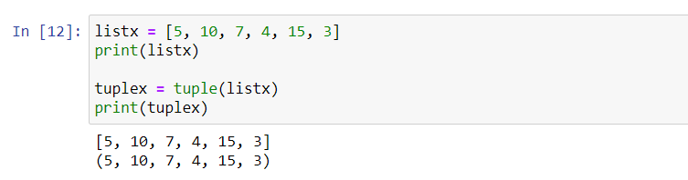

1. Write a Python program to remove an item from a tuple.

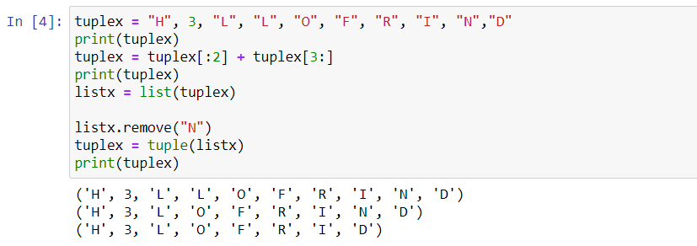

1. Write a Python program to slice a tuple

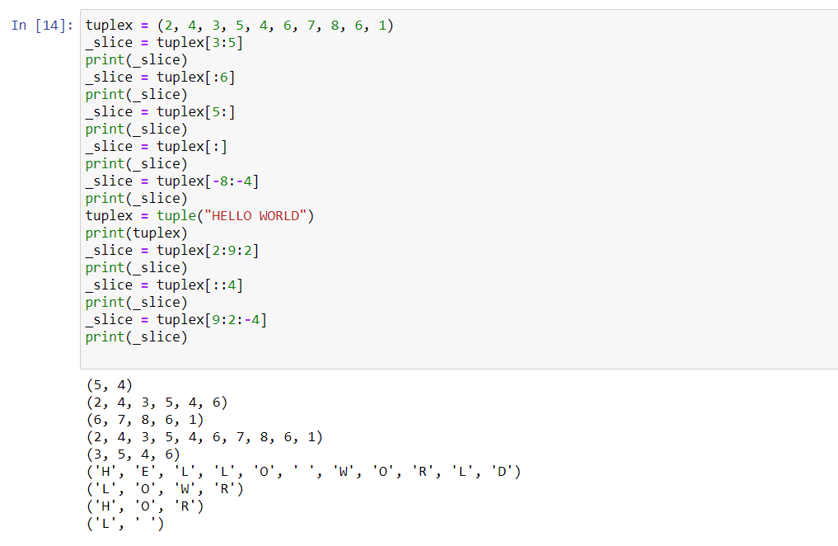

1. Write a Python program to find the index of an item of a tuple.

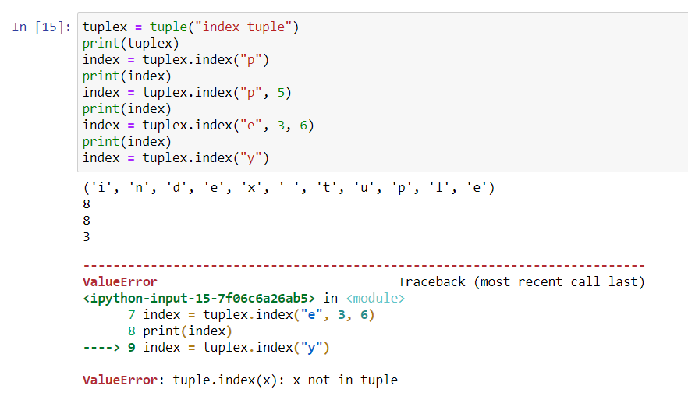

1. Write a Python program to find the length of a tuple.

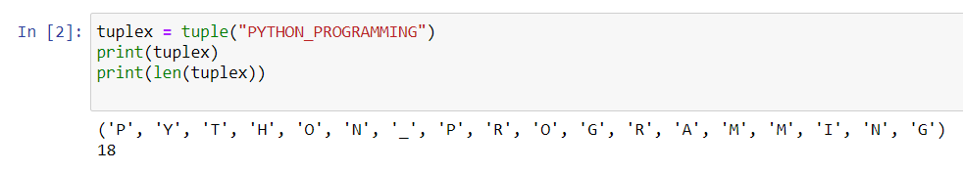

1. Write a Python program to reverse a tuple.

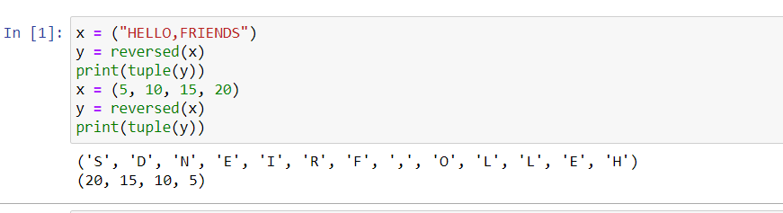

**Lab -5**

**List**

1. Write a Python program to sum all the items in a list.

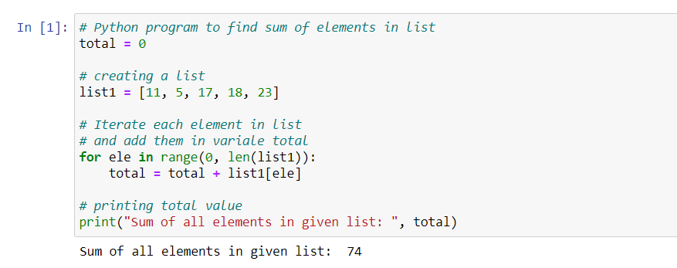

1. Write a Python program to multiplies all the items in a list.

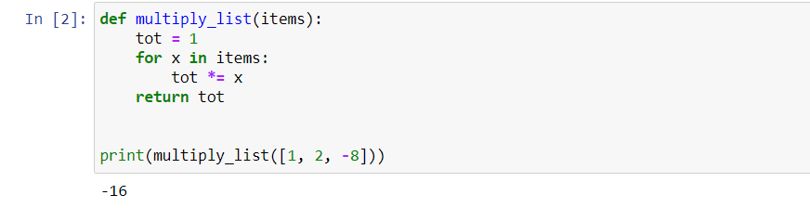

1. Write a Python program to get the largest number from a list

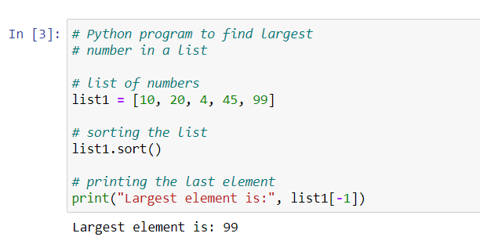

1. Write a Python program to get the smallest number from a list.

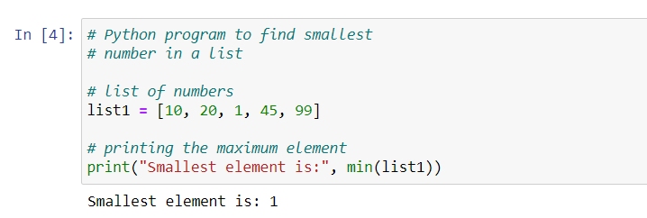

1. Write a Python program to count the number of strings where the string length is 2 or more and the first and last character are same from a given list of strings

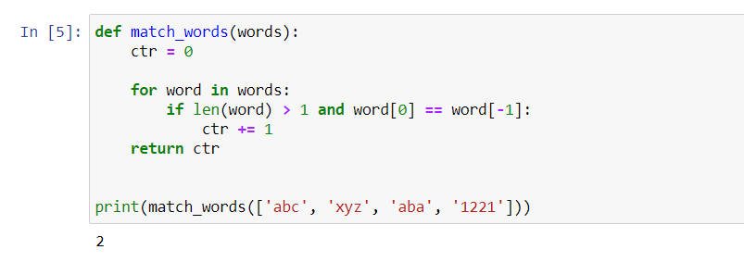

**6.** Write a Python program to get a list, sorted in increasing order by the last element in each tuple from a given list of non-empty tuples.

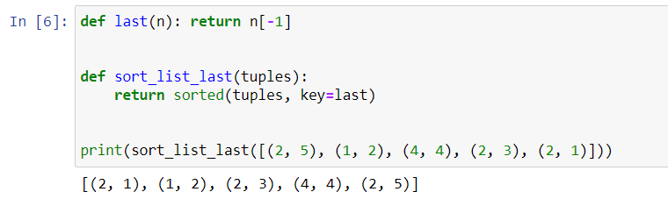

**7.**Write a Python program to remove duplicates from a list.

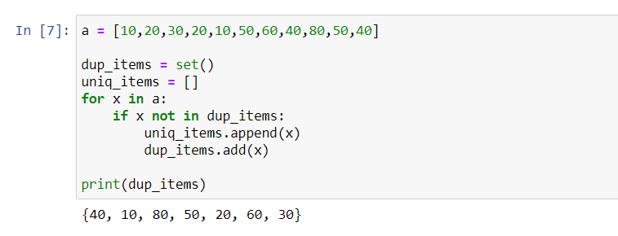

**8.**Write a Python program to check a list is empty or not.

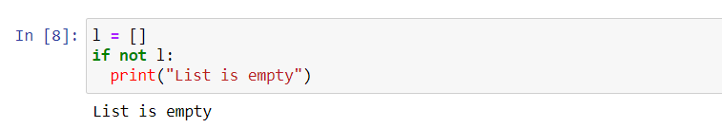

**9.**Write a Python program to clone or copy a list.

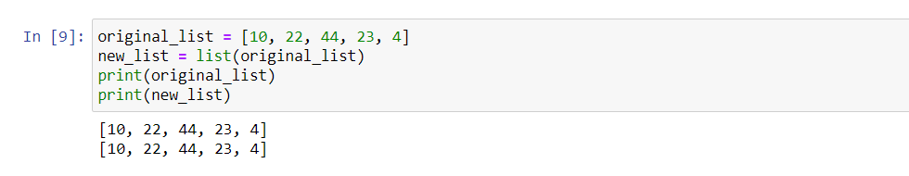

**10.**Write a Python program to find the list of words that are longer than n from a given list of words.

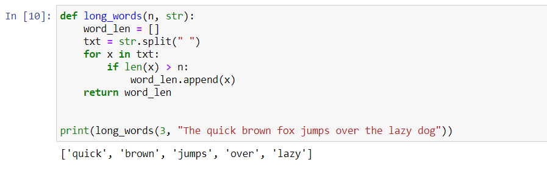

**11.**Write a Python function that takes two lists and returns True if they have at least one common member.

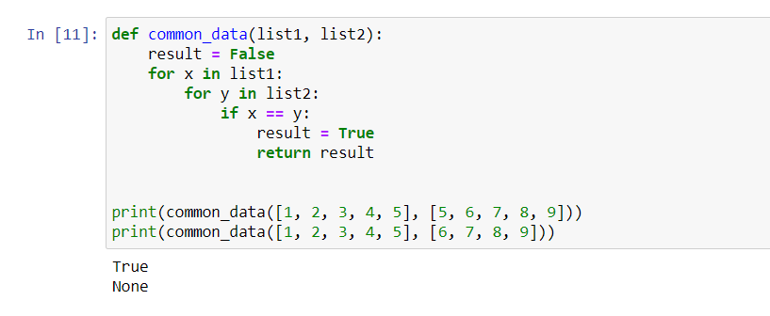

**12.**Write a Python program to print a specified list after removing the 0th, 4th and 5th elements. 

